**Q1 Write a program to implement the concept of the ElGamal Cryptosystem**

**Python code**

import random

from math import pow

a = random.randint(2, 10)

def gcd(a, b):

if a < b:

return gcd(b, a)

elif a % b == 0:

return b;

else:

return gcd(b, a % b)

# Generating large random numbers

def gen_key(q):

key = random.randint(pow(10, 20), q)

while gcd(q, key) != 1:

key = random.randint(pow(10, 20), q)

return key

# Modular exponentiation

def power(a, b, c):

x = 1

y = a

while b > 0:

if b % 2 == 0:

x = (x * y) % c;

y = (y * y) % c

b = int(b / 2)

return x % c

# Asymmetric encryption

def encrypt(msg, q, h, g):

en_msg = []

k = gen_key(q)# Private key for sender

s = power(h, k, q)

p = power(g, k, q)

for i in range(0, len(msg)):

en_msg.append(msg[i])

print("g^k used : ", p)

print("g^ak used : ", s)

for i in range(0, len(en_msg)):

en_msg[i] = s * ord(en_msg[i])

return en_msg, p

def decrypt(en_msg, p, key, q):

dr_msg = []

h = power(p, key, q)

for i in range(0, len(en_msg)):

dr_msg.append(chr(int(en_msg[i]/h)))

return dr_msg

# Driver code

def main():

msg = 'encryption'

print("Original Message :", msg)

q = random.randint(pow(10, 20), pow(10, 50))

g = random.randint(2, q)

key = gen_key(q)# Private key for receiver

h = power(g, key, q)

print("g used : ", g)

print("g^a used : ", h)

en_msg, p = encrypt(msg, q, h, g)

dr_msg = decrypt(en_msg, p, key, q)

dmsg = ''.join(dr_msg)

print("Decrypted Message :", dmsg);

if __name__ == '__main__':

main()

**OUTPUT**

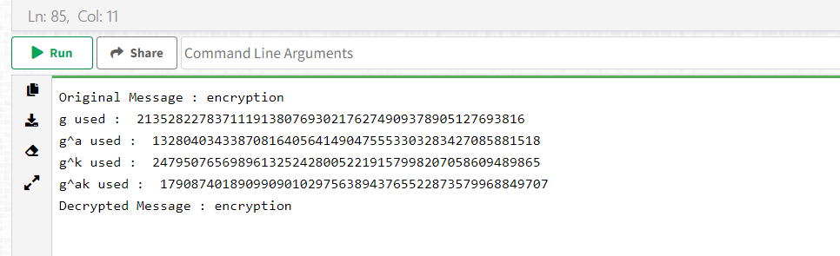

**Q2 Write a program to implement the concept of the Chinese Remainder Theorem**

**Java Code**

import java.util.*;

class CodeSpeedy{

static int CRT(int a[], int m[], int n, int p){

int x = 0;

for(int i = 0; i<n; i++){

int M = p/m[i], y = 0; // M1 = p/m1, M2 = p/m2 ....., Mn = p/mn

for(int j=0; j<m[i]; j++){

if((M*j)%m[i]==1){

y = j; break; // Finding the values for y1, y2,..., yn

}

}

x = x + a[i]*M*y; // x = a1*M1*y1 + a2*M2*y2 + ... + an*Mn*yn

}

return x%p;

}

public static void main(String args[]){

Scanner sc = new Scanner(System.in);

System.out.println("Enter the number of congruence relations: ");

int size = sc.nextInt();

System.out.println("Enter the values of a: ");

int a[] = new int[size];

for(int i=0; i<size; i++)

a[i] = sc.nextInt();

System.out.println("Enter the values of m: ");

int m[] = new int[size], p = 1;

for(int i=0; i<size; i++){

m[i] = sc.nextInt();

p = p*m[i]; // p = m1*m2*...*mn

}

System.out.println("The solution is "+CRT(a,m,size,p));

}

}

**OUTPUT**

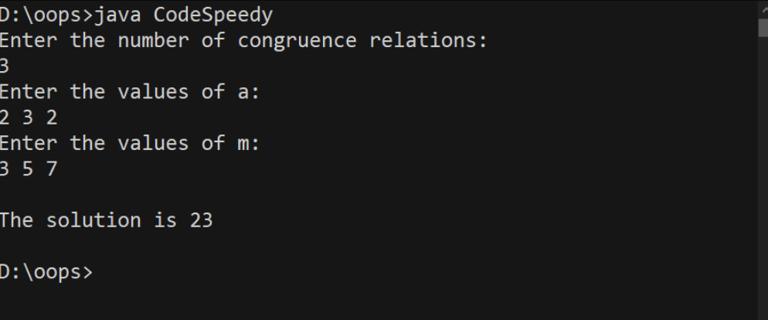

**Q3 Write a program to implement the concept of digital signature**

**Java Code**

// Java implementation for Generating

// and verifying the digital signature

package java_cryptography;

// Imports

import java.security.KeyPair;

import java.security.KeyPairGenerator;

import java.security.PrivateKey;

import java.security.PublicKey;

import java.security.SecureRandom;

import java.security.Signature;

import java.util.Scanner;

import javax.xml.bind.DatatypeConverter;

public class Digital_Signature_GeeksforGeeks {

// Signing Algorithm

private static final String

SIGNING_ALGORITHM

= "SHA256withRSA";

private static final String RSA = "RSA";

private static Scanner sc;

// Function to implement Digital signature

// using SHA256 and RSA algorithm

// by passing private key.

public static byte[] Create_Digital_Signature(

byte[] input,

PrivateKey Key)

throws Exception

{

Signature signature

= Signature.getInstance(

SIGNING_ALGORITHM);

signature.initSign(Key);

signature.update(input);

return signature.sign();

}

// Generating the asymmetric key pair

// using SecureRandom class

// functions and RSA algorithm.

public static KeyPair Generate_RSA_KeyPair()

throws Exception

{

SecureRandom secureRandom

= new SecureRandom();

KeyPairGenerator keyPairGenerator

= KeyPairGenerator

.getInstance(RSA);

keyPairGenerator

.initialize(

2048, secureRandom);

return keyPairGenerator

.generateKeyPair();

}

// Function for Verification of the

// digital signature by using the public key

public static boolean

Verify_Digital_Signature(

byte[] input,

byte[] signatureToVerify,

PublicKey key)

throws Exception

{

Signature signature

= Signature.getInstance(

SIGNING_ALGORITHM);

signature.initVerify(key);

signature.update(input);

return signature

.verify(signatureToVerify);

}

// Driver Code

public static void main(String args[])

throws Exception

{

String input

= "GEEKSFORGEEKS IS A"

+ " COMPUTER SCIENCE PORTAL";

KeyPair keyPair

= Generate_RSA_KeyPair();

// Function Call

byte[] signature

= Create_Digital_Signature(

input.getBytes(),

keyPair.getPrivate());

System.out.println(

"Signature Value:\n "

+ DatatypeConverter

.printHexBinary(signature));

System.out.println(

"Verification: "

+ Verify_Digital_Signature(

input.getBytes(),

signature, keyPair.getPublic()));

}

}

**OUTPUT**

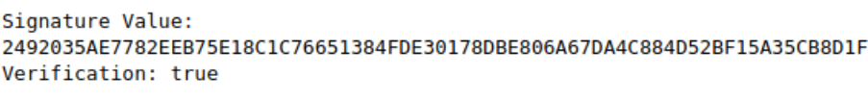

**Q4. Write a program for the Kerberos Authentication Protocol.**

**Python Code**

import datetime, random

class xor_cipher():

''' Very simple stream cipher '''

def __init__(self):

''' Basic stream cipher on ascii string and ascii key'''

pass

def ascii2bin(self, string):

''' Converts ascii string to binary bitstring '''

return ''.join('{:08b}'.format(ord(asc)) for asc in string)

def bin2ascii(self, binary):

''' Converts binary bitstring to ascii string '''

return ''.join(chr(int(binary[i:i+8], 2)) for i in range(0, len(binary), 8))

def bin2hex(self, bn):

''' Converts binary bitstring to hex string '''

return ''.join('{:x}'.format(int(bn[i:i+4], 2)) for i in range(0, len(bn), 4))

def hex2bin(self, hx):

''' Converts hex string to binary bitstring '''

return ''.join('{:04b}'.format(int(h, 16)) for h in hx)

def xor(self, a, b):

''' Performs XOR operation of given two inputs a, b '''

return ''.join('0' if i == j else '1' for i, j in zip(a, b))

def encrypt(self, message, key):

''' Performs encryption on message with key, this is xor operation between message and expanded key '''

# expanding key to the length of message

key += key*(len(message)-len(key))

# converting ascii strings to binary to perform XOR

message, key = self.ascii2bin(message), self.ascii2bin(key)

# performing xor operation

encrypted = self.xor(message, key)

# converting binary to hex string as cipher

return self.bin2hex(encrypted)

def decrypt(self, message, key):

''' Performs decryption on message with key, this is xor operation between message and expanded key '''

# expanding key to the length of message

key += key*(len(message)-len(key))

# converting hex message and ascii key to binary

message, key = self.hex2bin(message), self.ascii2bin(key)

# performing xor operation

decrypted = self.xor(message, key)

# converting binary to ascii as plain text

return self.bin2ascii(decrypted)

class user():

'''USER class'''

def __init__(self, name, authenticate_shared_key, database, nonce):

''' User is one participant in the network,

(name, authentication server shared key, database to communicate with, nonce) '''

self.name = name

self.auth_key = authenticate_shared_key

self.database = database

self.nonce = nonce

def prepare_auth_request(self):

''' Prepares request for authentication server '''

# returns a tuple with (name, database name, nonce)

return (self.name, self.database, self.nonce)

def process_auth_response(self, cipher1, cipher2):

''' Process the response from authentication server '''

# eval is used to extract tuple from string

response_to_user = eval(cipher.decrypt(cipher1, self.auth_key))

# unpacking tuple into individual elements, OBTAINED USER-TICKET KEY (common for user and TGS)!!

self.user_ticket_key, nonce, time, ttl, dest = response_to_user

# verify nonce

assert nonce == self.nonce

# verify destination name

assert dest == 'ticket_granting_server'

# 2nd element in response is ticket for TGS encrypted with TGS-auth key (common for TGS and auth)

self.ticket_granting_ticket = cipher2

return response_to_user

def prepare_ticket_request(self):

''' Prepare request for TGS '''

# request is a tuple with (name, time, database name, nonce)

request = str((self.name, str(datetime.datetime.now().date()), self.database, self.nonce))

# encrypt the request with user-ticket key (common for user and TGS)

encrypted_request = cipher.encrypt(request, self.user_ticket_key)

return (encrypted_request, self.ticket_granting_ticket)

def process_ticket_response(self, cipher1, cipher2):

''' Process the response from TGS '''

# extracting tuple from string

response_to_user = eval(cipher.decrypt(cipher1, self.user_ticket_key))

# unpacking elements into individual elements, "USER-DATABASE" key is obtained!! common for USER and DATABASE

self.user_database_key, nonce, time, life, destination = response_to_user

# 2nd response from TGS is a ticket for database encrypted with database-TGS key (common for database and TGS)

self.database_ticket = cipher2

# verify nonce

assert self.nonce == nonce

# verify database name

assert self.database == destination

# if everything is verified, which indicates user is authenticated, then create an object for database

# in practice, no such thing happens, because a physical database will be available

if self.database == destination:

num_db = dataserver()

# return the created object, which in practice returning the permission to access database

return num_db

def prepare_database_request(self):

''' Prepares a request for database '''

# create a random token, later used for acknowledgement purpose

self.token = random.randint(1, 100)

# create a request tuple with (name, token) for database

request = str((self.name, self.token))

# encrypt the request with user-database key, common for USER and DATABASE

encrypted_request = cipher.encrypt(request, self.user_database_key)

return (encrypted_request, self.database_ticket)

def process_database_response(self, response):

''' Process the database response'''

# verify is token is incremented by 1, which is ACKNOWLEDGEMENT

assert self.token+1 == response

def prepare_database_data_request(self, database, request):

''' Prepare data access requests for database'''

# data access requests and responses are encrypted with share (user-database) key

return cipher.encrypt(f'{database}.get_data({request})', self.user_database_key)

class authentication_server():

'''AUTHENTICATION SERVER class'''

def __init__(self):

''' Authentication Server, as a part of Key Disrtibution Centre (KDC), which authenticates users '''

# Authentication server should have the list of all shared passwords between users and Auth server

# TGS keys are inbuilt, as new users get added, their keys will be updated with set_key method

self.keys = {'tgs': 'tgs123'}

def set_key(self, name, key):

''' Sets new key for new users into network'''

self.keys[name] = key

def get_key(self, name):

''' Returns the user's key '''

return self.keys[name]

def process_request_respond(self, request):

''' Process the user request and respond '''

# unpack user request tuple into individual elements

self.client_name, self.destination, self.nonce = request

# return 2 encrypted responses, one for user (encrypted with user-auth key), another for TGS (encrypted with tgs_auth key)

return (self.response_for_user(), self.response_for_TGS())

def response_for_user(self):

''' Prepare a response for user '''

# create a random new key as a common key for USER and TGS

self.user_ticket_key = str(random.randint(1, 100))

# create a response tuple with (user-ticket key, nonce, time, span, TGS name)

response = (self.user_ticket_key, self.nonce, str(datetime.datetime.now().date()), '3 days', 'ticket_granting_server')

# since, this is response for user, it is encrypted with common key of auth-server and user

return cipher.encrypt(str(response), self.keys[self.client_name])

def response_for_TGS(self):

''' Prepare a response for TGS '''

# create a response tuple with (user-ticket key, client name, span)

response = (self.user_ticket_key, self.client_name, '3 days')

# since, this response is for TGS, it is encrypted with common key of auth-server and TGS

return cipher.encrypt(str(response), self.keys['tgs'])

class ticket_granting_server():

'''TICKET GRANTING SERVER class'''

def __init__(self):

''' Ticket Granting Server (TGS), as a part of Key Distribution Centre (KDC), which creates session keys between users'''

# personal key for TGS to communicate with Authentication Server

self.personal_key = 'tgs123'

# database keys at TGS

self.keys = {'number_database': 'alpha'}

def process_auth_user_request_respond(self, user_request, auth_response):

''' Process user_request and auth_response_for_TGS and respond'''

# decrypt and exrtact the tuple with personal key, as this is encrypted by auth server

auth_response = eval(cipher.decrypt(auth_response, self.personal_key))

# unpack auth response into individual elements, obtained USER-TICKET key (common for user and TGS)

self.user_ticket_key, client_name, life = auth_response

# decrypt and extract user request with USER-TICKET key obtained in above auth response

user_request = eval(cipher.decrypt(user_request, self.user_ticket_key))

# unpack user request into individual elements

self.user_name, time, self.destination, self.nonce = user_request

# return two encrypted responses, one for user (encrypted with user-tgs key), another for database (with database-tgs key)

return (self.response_for_user(), self.response_for_database())

def response_for_user(self):

''' Prepare a response for USER '''

# create a key common key for USER - DATABASE

self.user_database_key = str(random.randint(1, 100))

# create response data tuple with (user-database key, nonce, time, span, database name)

response = str((self.user_database_key, self.nonce, str(datetime.datetime.now().date()), '5 days', self.destination))

# encrypt the response with USER-TGS key, common for user and TGS.

return cipher.encrypt(response, self.user_ticket_key)

def response_for_database(self):

''' Prepare a response for DATABASE '''

# create a response tuple with (user-database key, user name, span)

response = str((self.user_database_key, self.user_name, '5 days'))

# encrypt response with DATABASE-TGS key, common for TGS and Database

return cipher.encrypt(response, self.keys[self.destination])

class dataserver():

''' DATASERVER class '''

def __init__(self):

''' This can be another participant or a data server in a network '''

# this personal key is pre-shared with TGS

self.personal_key = 'alpha'

# example data in database

self.data = {1: 'One', 2: 'Two', 3: 'Three'}

def __str__(self):

return 'number_database'

def get_data(self, index):

''' Get the data from database '''

# verify if request is valid

assert index in self.data.keys()

# return data

return self.data[index]

def process_client_request_respond(self, client_token, db_ticket):

''' Process client request and respond '''

# process db ticket

# db_ticket is dedicated for database, which can be decrypted with database's personal key

db_ticket = eval(cipher.decrypt(db_ticket, self.personal_key))

# unpack into individual elements, obtained USER-DATABASE key !!

self.user_database_key, user_name, life = db_ticket

# process client token

# decrypt client token with user-database key obtained in above ticket

client_token = eval(cipher.decrypt(client_token, self.user_database_key))

# unpack token into individual elements

self.client_name, self.token = client_token

# verify name

assert self.client_name == user_name

# if name is valid, then acknowledge user by incrementing token by 1

return self.token + 1

def process_data_request_respond(self, request):

'''Process data request and respond '''

# decrypt the user request with user-database key and evaluate the request

return eval(cipher.decrypt(request, self.user_database_key))

# setup ciphering function

cipher = xor_cipher()

# setup database server

# this is created as a string, to verify across the process

# database object is created when requesting user is authenticated in later steps

db = 'number_database'

# setup user

username = 'ajay'

userkey = 'secret_key'

user1 = user(username, userkey, db, 12)

# setup authentication server

auth_server = authentication_server()

# add user with key in authentication server

auth_server.set_key(username, userkey)

# setup ticket granting server

ticket_server = ticket_granting_server()

# KERBEROS PROTOCOL

# prepare auth request -> send to auth server -> auth authenticates and responds -> process the auth response

user_request_to_auth = user1.prepare_auth_request()

response_to_user_from_auth, response_to_tgs_from_auth = auth_server.process_request_respond(user_request_to_auth)

auth_response_to_user = user1.process_auth_response(response_to_user_from_auth, response_to_tgs_from_auth)

# prepare tgs request -> send to tgs -> tgs process tickets and responds -> process the tgs response

user_request_to_tgs, ticket_request_from_auth = user1.prepare_ticket_request()

response_to_user_from_tgs, response_to_db_from_tgs = ticket_server.process_auth_user_request_respond(user_request_to_tgs, ticket_request_from_auth)

database1 = user1.process_ticket_response(response_to_user_from_tgs, response_to_db_from_tgs)

# prepare database request -> send to database -> database acknowledges and responds -> process the response

user_request_to_db, db_ticket_from_tgs = user1.prepare_database_request()

database_response = database1.process_client_request_respond(user_request_to_db, db_ticket_from_tgs)

user1.process_database_response(database_response)

# verify user and database successfully shared common keys

assert user1.user_database_key == database1.user_database_key

print('Key Establishment successful..!')

# request data from database

request_data = 1

request = user1.prepare_database_data_request('database1', request_data)

response = database1.process_data_request_respond(request)

# enjoy response

print(request_data, response)

**OUTPUT**

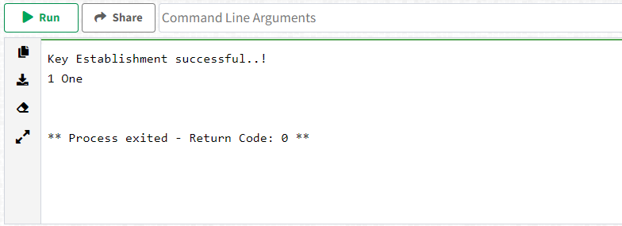

**Name - Bipul Sharma**

**Roll No. - 19115018**